**University of Petroleum and Energy Studies**

School of Computer Science

Department of Cybernetics



**Graphics & Animation Tools**

**LAB FILE**

**(Session: 2020-2021)**

Course: B. Tech with Specialization in Open Source and Open Standards





**Experiment 5: Design of 3D Text using Blender.**

**STEPS:-**

1. Open a new general file and delete the basic layout i.e. cube, light and camera.
2. Add some text by pressing shift+A and then writing the desired text by pressing Tab. Also add some geometry and alignment to it.
3. Add a light and a circle so that the light would follow the circle. To do this, add an object constraint “Follow path” to the light and the target being the circle.
4. Add a camera and move it to the centre to make it look at the text. Adjust its movement, rotation by pressing G and R.
5. Adjust the scale and movement of the circle in order to make it close to the text. To animate it, insert keyframes at the beginning and the end of the timeline.
6. Adjust the power, colour and give some material properties to the point light following the path.
7. Add some shading factor to the text by going to the shading workspace and adding nodes like the noise texture, bump, mapping and texture coordinates.
8. Add some more keyframes at several points in the timeline to give it the final cinematic preview.
9. Play the animation in the rendered viewport.

**Output:**

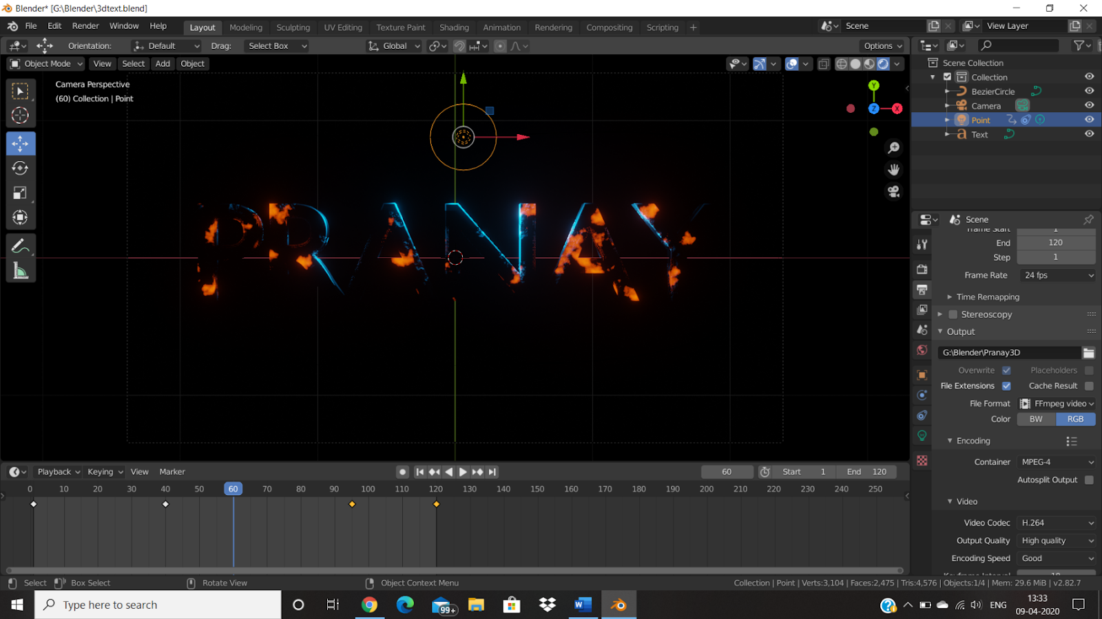

**Link to Drive Folder:**

[**Graphics and Animation Tools**](https://drive.google.com/drive/folders/1L1gqtxnW8xDUk-jw3Z8dTLz2_Yth1-OI?usp=sharing)